Lab 04 — OneLake Storage Optimization and Delta Lake Performance Engineering

Lab Information
Property | Value
Module | OneLake Storage Optimisation
Lab Number | 04
Lab Name | OneLake Storage Optimization and Delta Lake Performance Engineering
Difficulty | Advanced
Primary Technology | Microsoft Fabric Lakehouse
Compute | Apache Spark — Fabric Runtime 2.0
Storage | OneLake / Delta Lake / Parquet
APIs | PySpark / Delta Lake APIs / Spark SQL
Automation | Fabric Data Pipelines
Primary Outcome | Optimize an existing Delta table, compare physical-layout strategies, measure performance/write amplification, and automate maintenance
Runtime note: Fabric Runtime 2.0 is currently Public Preview. Current Microsoft documentation identifies it as Spark 4.1 and Delta Lake 4.2. The lab therefore requires a designated Runtime 2.0 lab environment. (Microsoft Learn)

1. Learning Objectives
By the end of the lab, the learner will have:
- inspected the physical Delta/Parquet layout of an existing Lakehouse table;
- established a measurable performance baseline;
- inspected Delta transaction history and operation metrics;
- validated V-Order configuration;
- executed and measured Delta table compaction;
- evaluated Z-Order against Liquid Clustering;
- configured Liquid Clustering on a suitable existing table;
- executed incremental OPTIMIZE;
- evaluated clustering quality;
- inspected Spark execution plans;
- measured write amplification;
- executed safe VACUUM maintenance;
- built a Fabric Data Pipeline for recurring maintenance;
- validated failure and recovery;
- produced before/after optimization evidence.

2. Business Scenario
The enterprise Lakehouse contains a heavily queried Delta table that has accumulated many data files through repeated ingestion and update operations.
The analytics team reports:
- increasing query latency;
- excessive small files;
- repeated compaction requirements;
- increasing storage consumption;
- unpredictable maintenance cost;
- inconsistent performance across workloads.
You are the data platform engineer responsible for determining which physical-layout strategy should be used and how maintenance should be automated.
You will work only with the existing lab table.
Do not create sample data.

3. Starting Environment
The instructor must provide:
Fabric Workspace
│
├── Environment configured for Runtime 2.0
│
├── Lakehouse
│ └── Existing Delta table
│
├── Notebook
│
└── Pipeline workspace
Required:
- Fabric workspace
- Lakehouse containing an existing Delta table
- sufficiently large table for meaningful optimization
- existing workload/query pattern
- Fabric Environment configured for Runtime 2.0
- permission to execute Spark operations
- permission to create/run pipelines
- safe lab table on which OPTIMIZE and VACUUM can be performed

Important
The target table must not be a production table.
OPTIMIZE, clustering and VACUUM physically modify/clean table storage. The lab must use an instructor-designated table.

PHASE 1 — Environment and Runtime Validation

STEP 01 — Open the Assigned Fabric Workspace

Where
Microsoft Fabric → Workspaces

Actions
- Open the assigned training workspace.
- Locate the designated Lakehouse.
- Open the Lakehouse.
- Confirm that the Tables section contains the instructor-designated optimization table.
- Record the exact table name.
For the rest of the lab, use:
table_name = "<INSTRUCTOR_TABLE_NAME>"
Do not replace this with a fabricated table name.

Expected Output
The target table is visible under:
Lakehouse
└── Tables
└── <target table>

STEP 02 — Open the Fabric Environment

Where
Workspace → Environment

Actions
- Open the environment attached to the lab.
- Open the environment configuration.
- Locate the Runtime configuration.
- Verify:
Runtime: 2.0 Public Preview
- Record the runtime version.
Microsoft currently documents Runtime 2.0 as Public Preview with Spark 4.1 and Delta Lake 4.2. (Microsoft Learn)
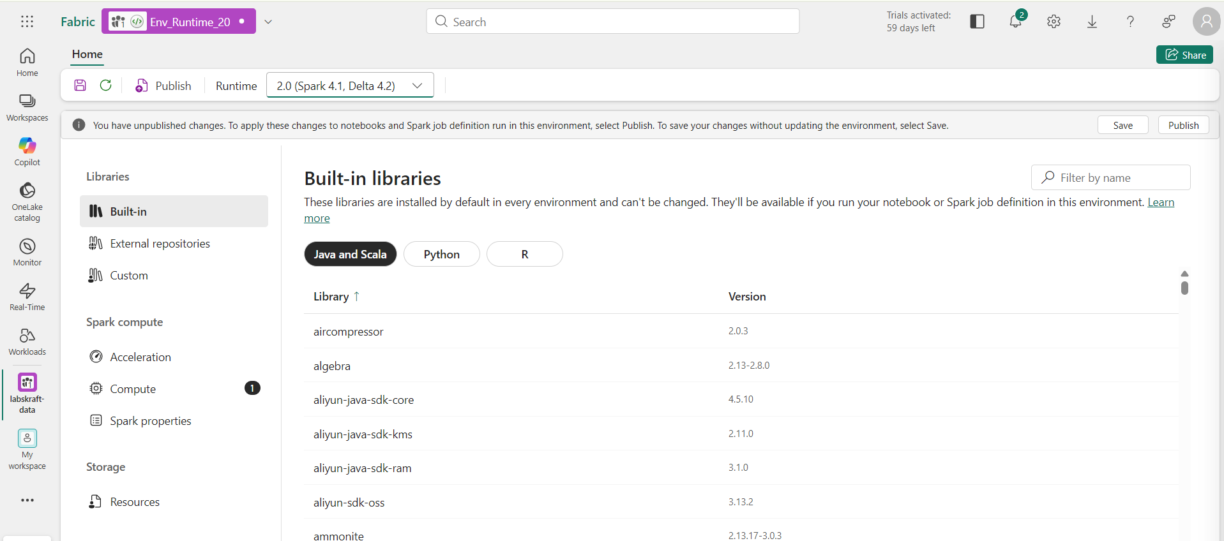

Expected Output
You should see the Runtime 2.0 configuration.

Evidence
Capture the Runtime configuration.

PHASE 2 — Create the Optimization Notebook

STEP 03 — Create the Optimization Notebook

Where
Workspace → New → Notebook
Name:
NB_OneLake_Storage_Optimization
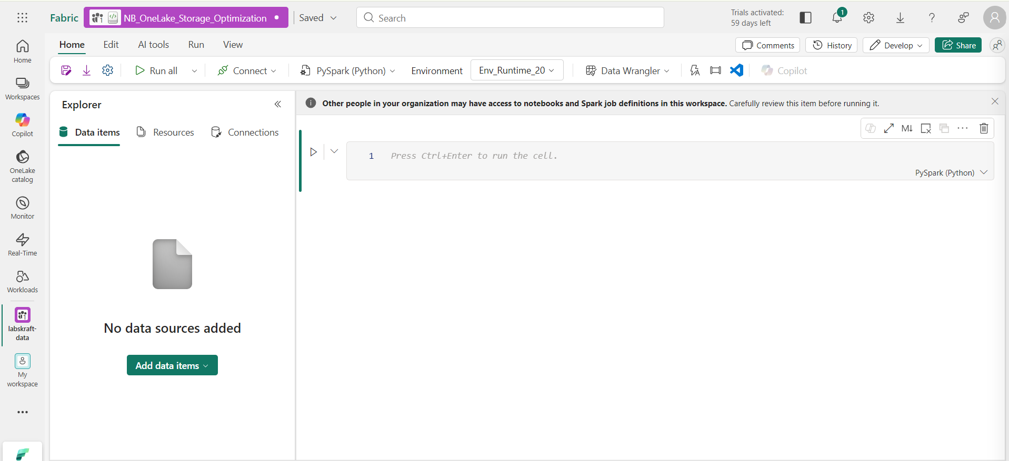

Actions
- Create the notebook.
- Attach the designated Lakehouse.
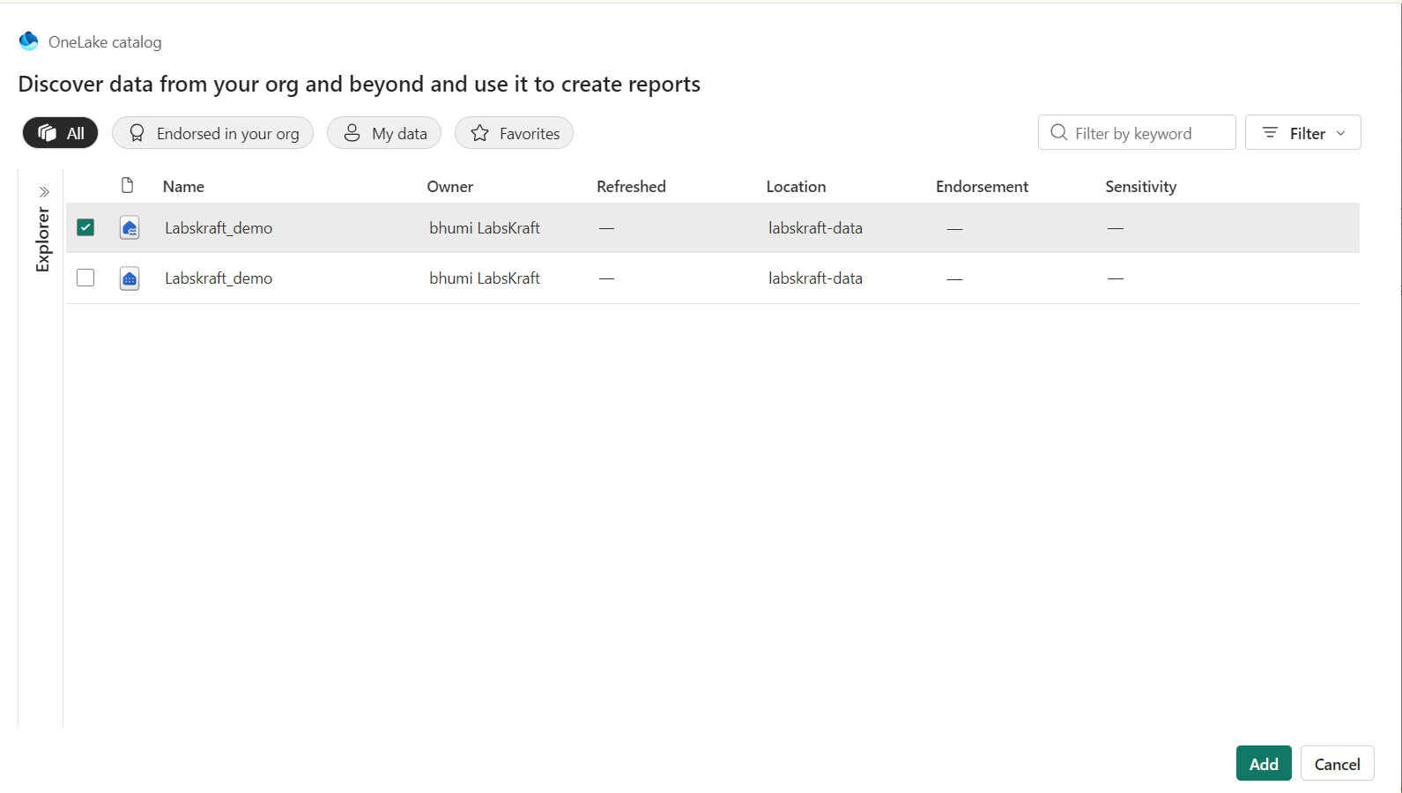
- Select the Runtime 2.0 environment.
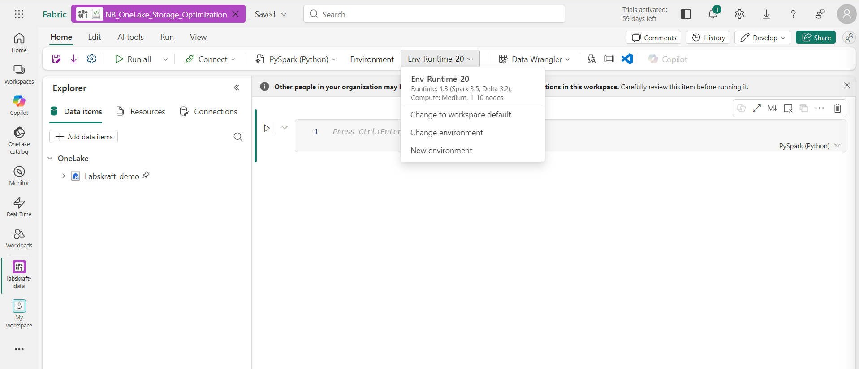
- Start the Spark session.

STEP 04 — Validate Spark and Delta Runtime

Where
Notebook → PySpark cell
Run:
print("Spark version:", spark.version)

print("\nRelevant Spark configuration:")
for key, value in sorted(spark.sparkContext.getConf().getAll()):
if (
"spark.sql" in key
or "delta" in key.lower()
or "native" in key.lower()
):
print(f"{key} = {value}")

Expected Output
The Spark version should correspond to the Runtime 2.0 environment.
Current Microsoft documentation identifies Runtime 2.0 with Apache Spark 4.1. (Microsoft Learn)

Validation
Record:
Spark Version:
Runtime:
Delta Version:
Native Execution Engine:
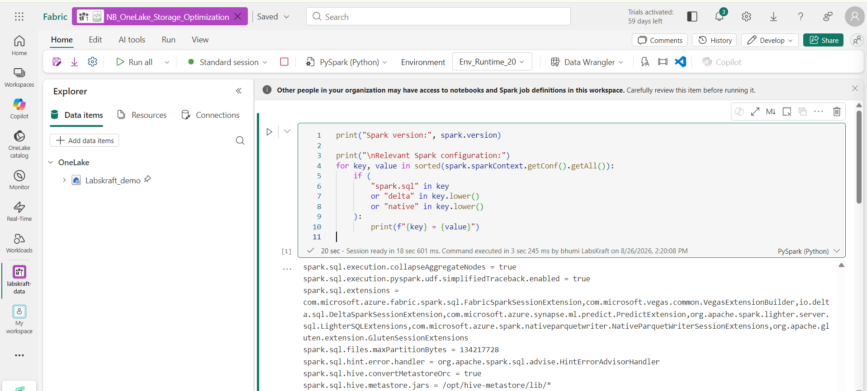

PHASE 3 — Inspect Delta Table Internals

STEP 05 — Validate the Table
Run:
table_name = "<INSTRUCTOR_TABLE_NAME>"

spark.sql(f"""
DESCRIBE DETAIL {table_name}
""").show(truncate=False)

Inspect
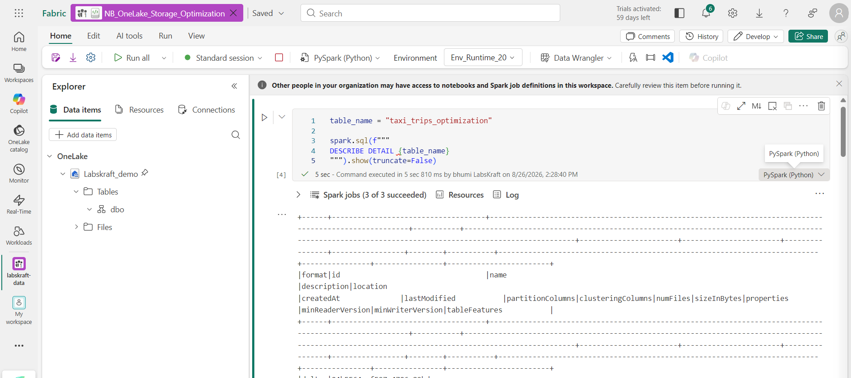
Look specifically for:
- format
- location
- number of files
- size
- partition columns
- table properties

Expected Output
The table should report:
format = delta

STEP 06 — Inspect the Delta Transaction History
Run:
history_df = spark.sql(f"""
DESCRIBE HISTORY {table_name}
""")

history_df.show(20, truncate=False)

Inspect
Look for operations such as:
WRITE
UPDATE
MERGE
DELETE
OPTIMIZE
VACUUM
depending on the table's actual history.

Validation
Run:
history_df.select(
"version",
"timestamp",
"operation",
"operationMetrics"
).show(20, truncate=False)
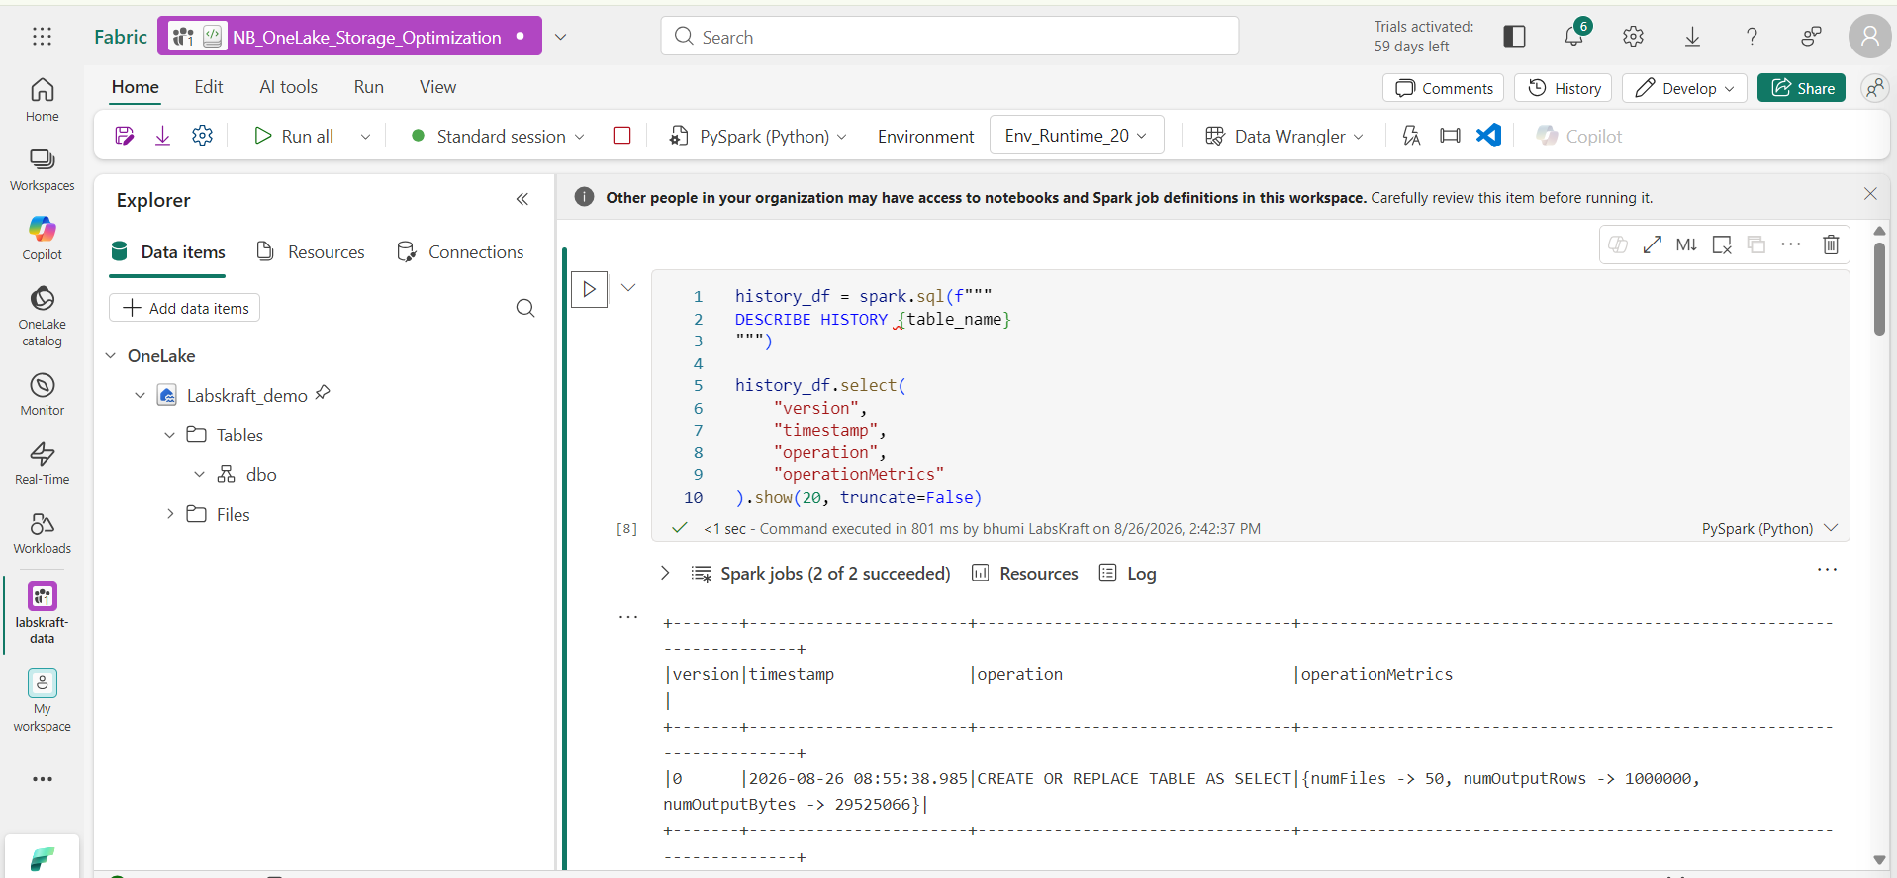

Expected Output
You should obtain the actual transaction history of the existing table.
This establishes the connection between:
Logical operation
↓
Delta transaction
↓
Physical files

PHASE 4 — Establish the Baseline

STEP 07 — Record Current Table Metrics
Run:
detail_df = spark.sql(f"""
DESCRIBE DETAIL {table_name}
""")

detail_df.select(
"format",
"numFiles",
"sizeInBytes",
"partitionColumns",
"location"
).show(truncate=False)
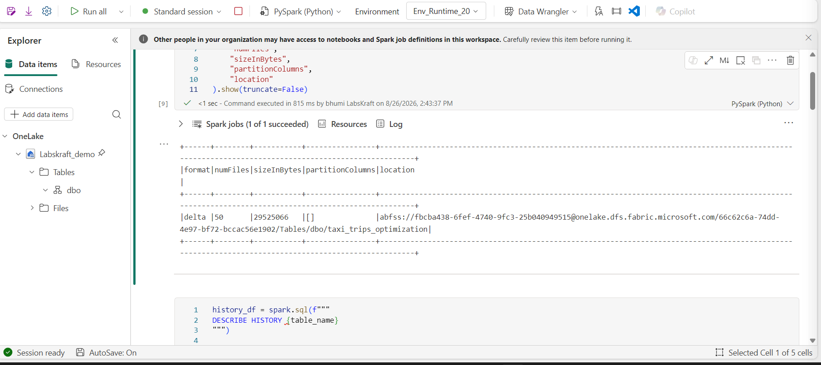
Record:
Metric | Baseline
Format
File count
Size
Partition columns
Location

STEP 08 — Inspect File Distribution
Run:
df = spark.table(table_name)

print("Number of Spark partitions:", df.rdd.getNumPartitions())

files = df.inputFiles()

print("Referenced files:", len(files))

for file_path in files[:20]:
print(file_path)

Expected Output
You should see the physical files referenced by the Delta table.

Evidence
Record:
- number of referenced files;
- representative file paths;
- partition directory structure if present.

STEP 09 — Inspect File Size Distribution
Run:
from pyspark.sql import functions as F

file_df = (
spark.read.format("binaryFile")
.load(files)
.select("path", "length")
)

file_df.select(
F.count("*").alias("file_count"),
F.min("length").alias("min_bytes"),
F.max("length").alias("max_bytes"),
F.avg("length").alias("avg_bytes")
).show()
Then:
file_df.orderBy("length").show(20, truncate=False)

What to look for
Identify whether the table contains:
- many small files;
- highly variable file sizes;
- relatively well-compacted files.
This is the actual small-file baseline.
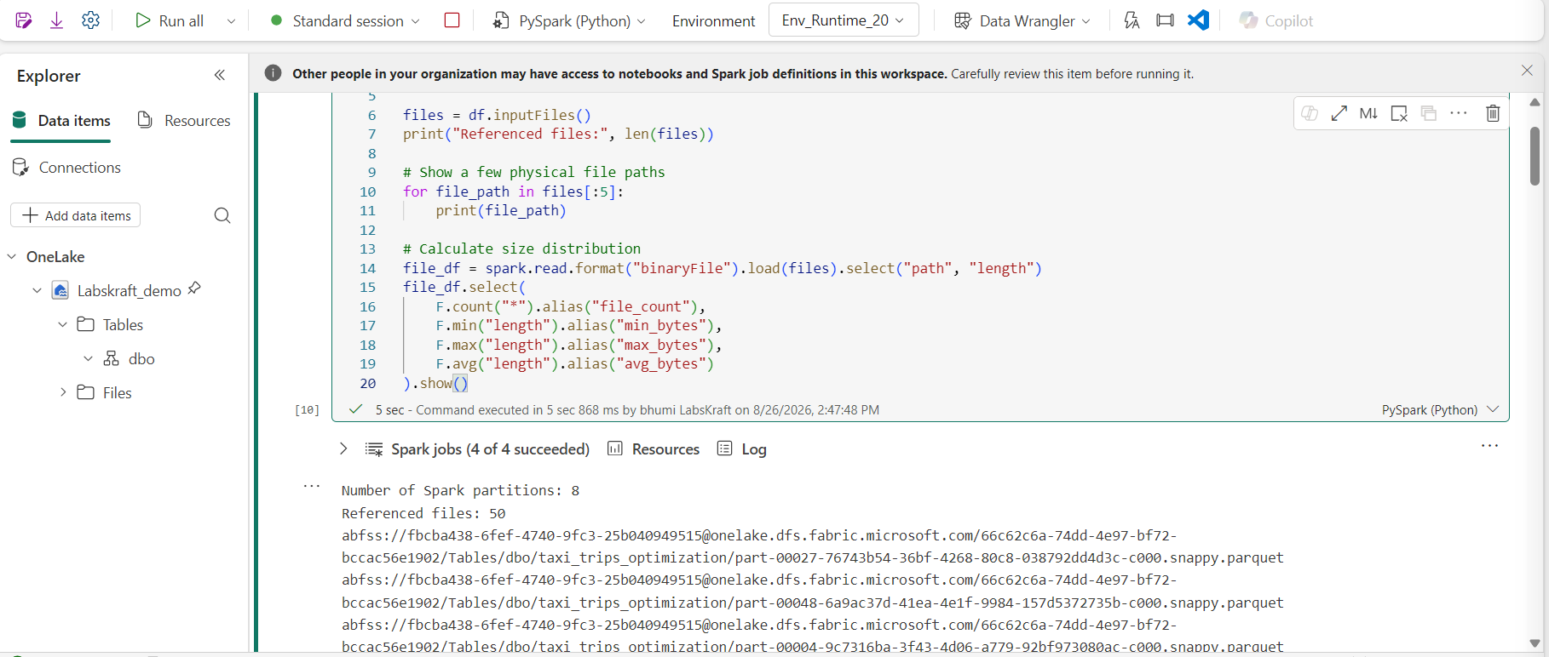

PHASE 5 — Baseline Query Performance

STEP 10 — Execute the Existing Analytical Workload
Use the instructor-provided workload.
Example structure:
from time import perf_counter

start = perf_counter()

result = (
spark.table(table_name)
.filter("<EXISTING_FILTER_PREDICATE>")
.groupBy("<EXISTING_GROUP_COLUMN>")
.count()
)

result.collect()

elapsed = perf_counter() - start

print(f"Execution time: {elapsed:.2f} seconds")
Important: Replace the placeholders with columns that actually exist in the instructor table.
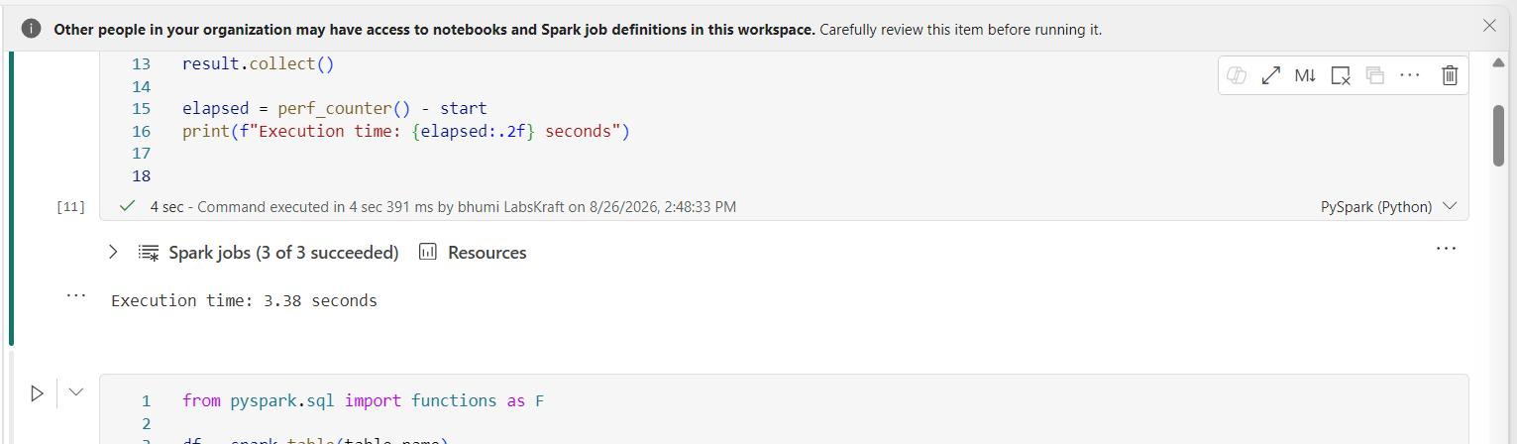

Capture
Execution time:
Files scanned:
Bytes scanned:
Shuffle:
Stages:

STEP 11 — Inspect the Execution Plan
Run:
result.explain("formatted")

Inspect
Look for:
Scan
Filter
Exchange
Aggregate
Shuffle
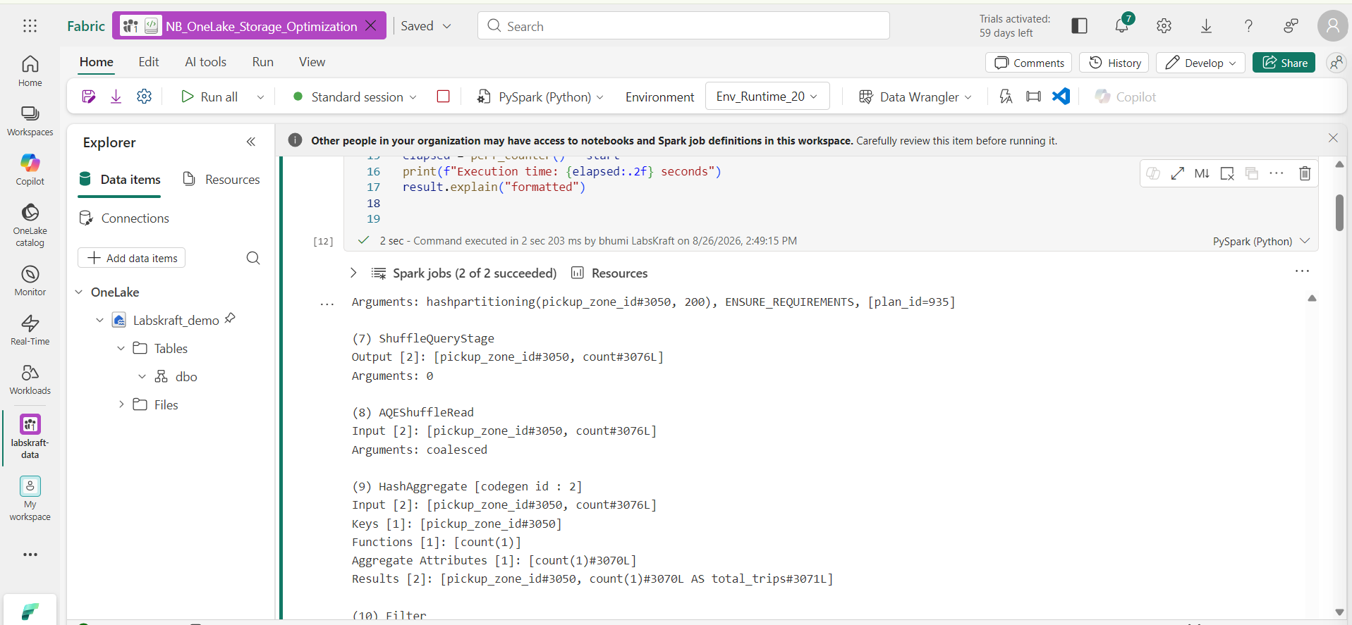
Pay particular attention to whether the filter can eliminate unnecessary files.

PHASE 6 — V-Order Engineering

STEP 12 — Inspect Current V-Order Configuration
Run:
spark.sql(f"""
SHOW TBLPROPERTIES {table_name}
""").show(truncate=False)
Look for:
delta.parquet.vorder.enabled
Also inspect:
print(
"Session V-Order:",
spark.conf.get(
"spark.sql.parquet.vorder.default",
"not explicitly configured"
)
)
Microsoft currently documents spark.sql.parquet.vorder.default as the session-level control and delta.parquet.vorder.enabled as the table-level control. (Microsoft Learn)

STEP 13 — Enable V-Order at Table Level
Only perform this on the designated lab table.
Run:
spark.sql(f"""
ALTER TABLE {table_name}
SET TBLPROPERTIES (
'delta.parquet.vorder.enabled' = 'true'
)
""")
Validate:
spark.sql(f"""
SHOW TBLPROPERTIES {table_name}
""").show(truncate=False)

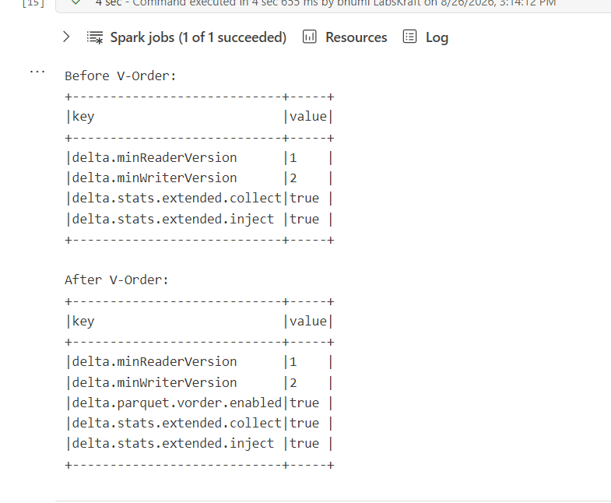

Expected Output
The property should show:
delta.parquet.vorder.enabled = true
V-Order affects Parquet physical layout at write time; it is not simply a query-time switch. (Microsoft Learn)

PHASE 7 — Delta Compaction

STEP 14 — Inspect Current Maintenance State
Run:
spark.sql(f"""
DESCRIBE HISTORY {table_name}
""").select(
"version",
"timestamp",
"operation",
"operationMetrics"
).show(10, truncate=False)
Record the latest state before optimization.
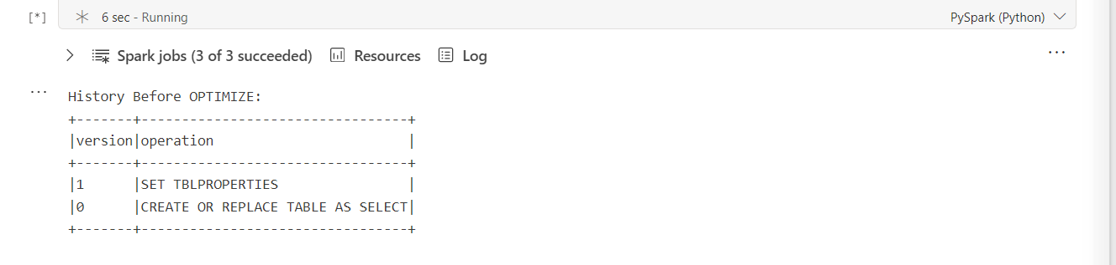

STEP 15 — Execute OPTIMIZE
Run:
spark.sql(f"""
OPTIMIZE {table_name}
""")

Wait for completion.
Then run:
spark.sql(f"""
DESCRIBE HISTORY {table_name}
""").select(
"version",
"timestamp",
"operation",
"operationMetrics"
).show(5, truncate=False)
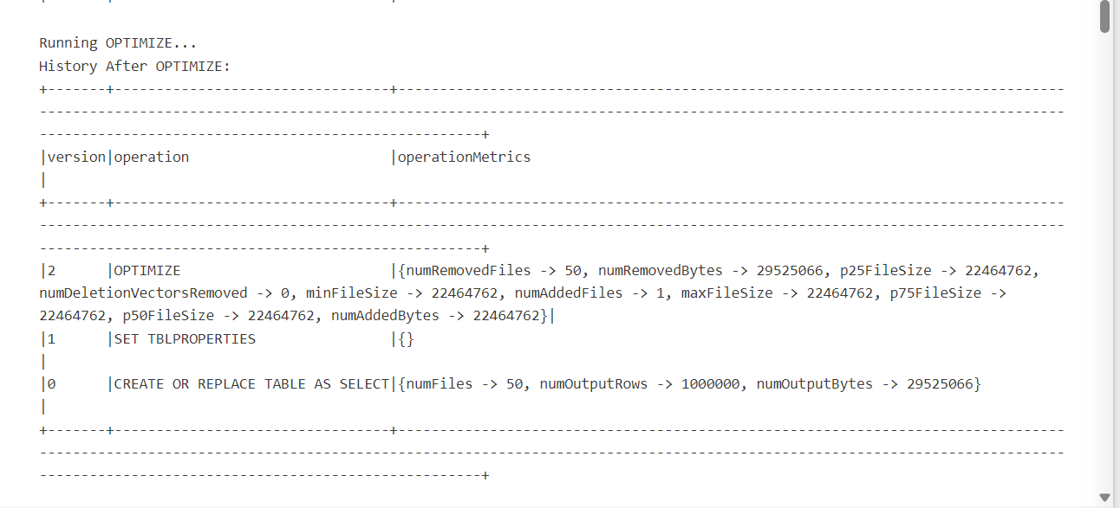

Validation
Confirm the newest operation is:
OPTIMIZE
Then inspect the operation metrics.

STEP 16 — Measure File Reduction
Run again:
spark.sql(f"""
DESCRIBE DETAIL {table_name}
""").select(
"numFiles",
"sizeInBytes"
).show()
Compare:
Before OPTIMIZE
After OPTIMIZE
Then inspect:
files_after = spark.table(table_name).inputFiles()

print("Files after OPTIMIZE:", len(files_after))

Deliverable
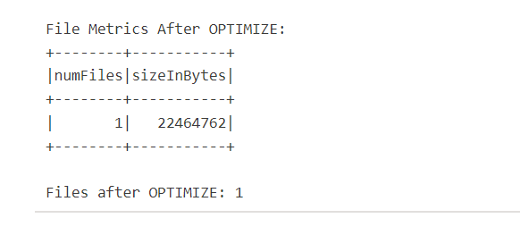Record:
Metric | Before | After
File count
Table size
Query duration

PHASE 8 — Z-Order Engineering

STEP 17 — Identify Candidate Columns
First inspect the schema:
spark.table(table_name).printSchema()
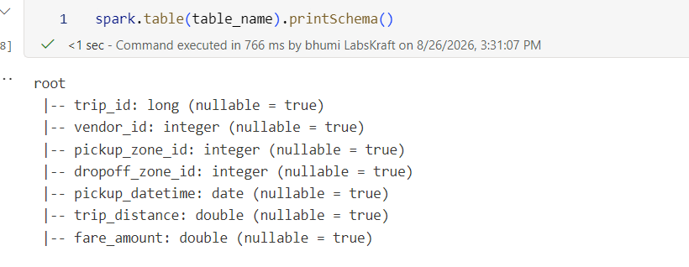
Then inspect the workload and identify 1–4 frequently filtered columns.
Microsoft currently recommends selecting columns that frequently appear in WHERE predicates; Z-Order can also be scoped with WHERE. (Microsoft Learn)
Document:
Candidate 1:
Candidate 2:
Candidate 3:
Candidate 4:

STEP 18 — Execute Z-Order
For the designated test table/workload, execute:
spark.sql(f"""
OPTIMIZE {table_name}
ZORDER BY (<COLUMN_1>, <COLUMN_2>)
""")
Replace the columns with actual columns from the table.

Validate
spark.sql(f"""
DESCRIBE HISTORY {table_name}
""").select(
"version",
"timestamp",
"operation",
"operationMetrics"
).show(5, truncate=False)
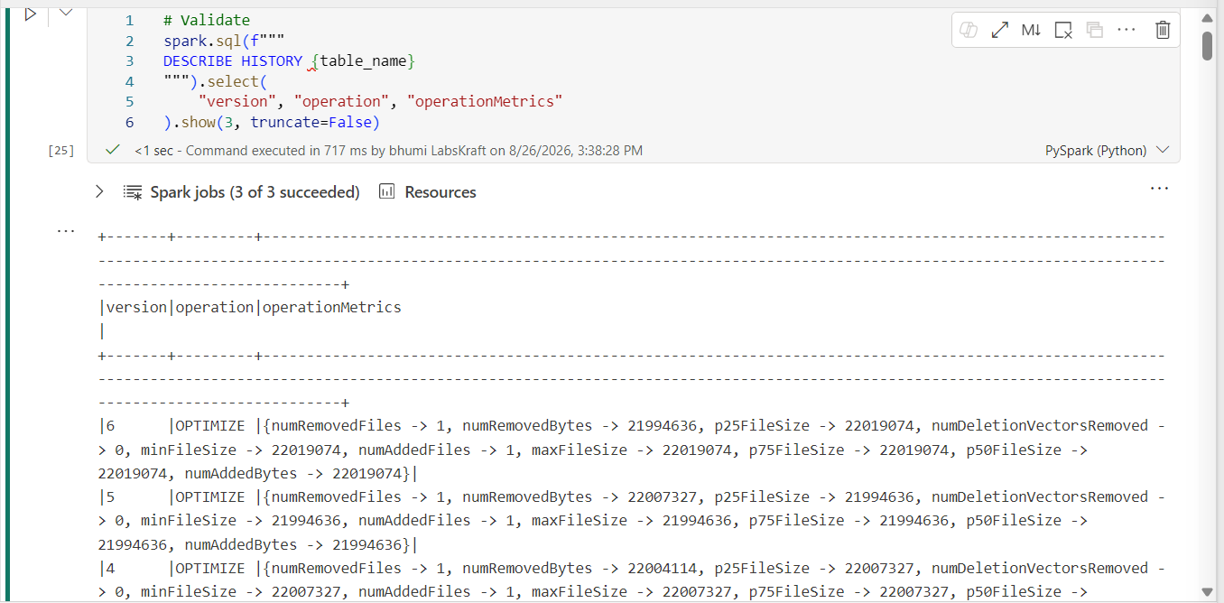

STEP 19 — Re-run the Baseline Workload
Run the same query from STEP 10.
Do not change:
- filter;
- grouping;
- selected columns;
- workload shape.
Capture:
Execution time:

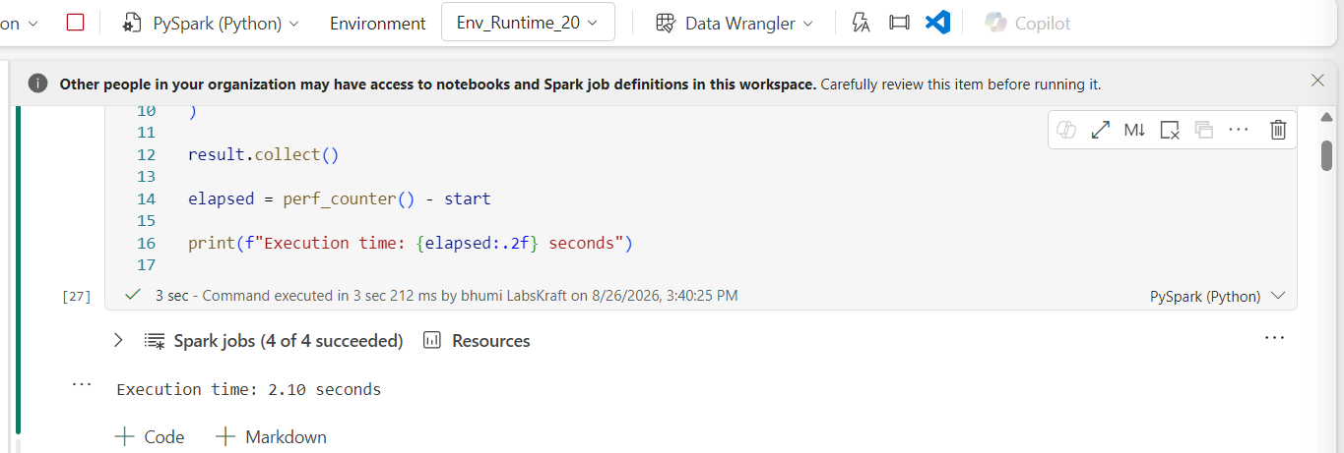
This gives you an actual before/after comparison.

PHASE 9 — Liquid Clustering

STEP 20 — Check Whether the Table Is Suitable
Run:
spark.sql(f"""
DESCRIBE DETAIL {table_name}
""").show(truncate=False)
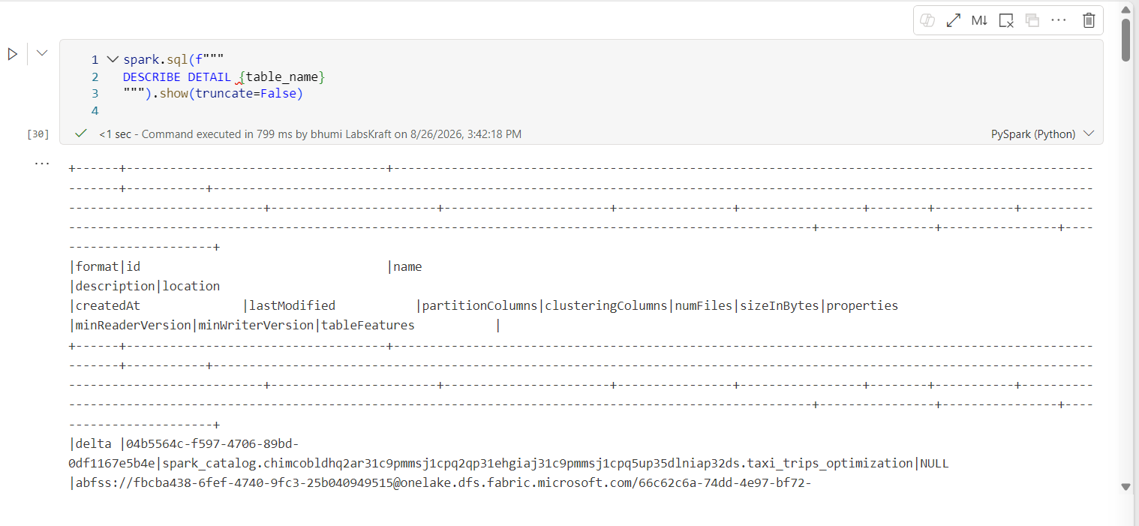
Check whether the table is partitioned.
Liquid clustering and Hive-style partitioning are not interchangeable; current Microsoft guidance recommends liquid clustering for many Runtime 2.0 read-optimization scenarios. (Microsoft Learn)

STEP 21 — Inspect Existing Clustering Definition
Run:
spark.sql(f"""
SHOW TBLPROPERTIES {table_name}
""").show(truncate=False)
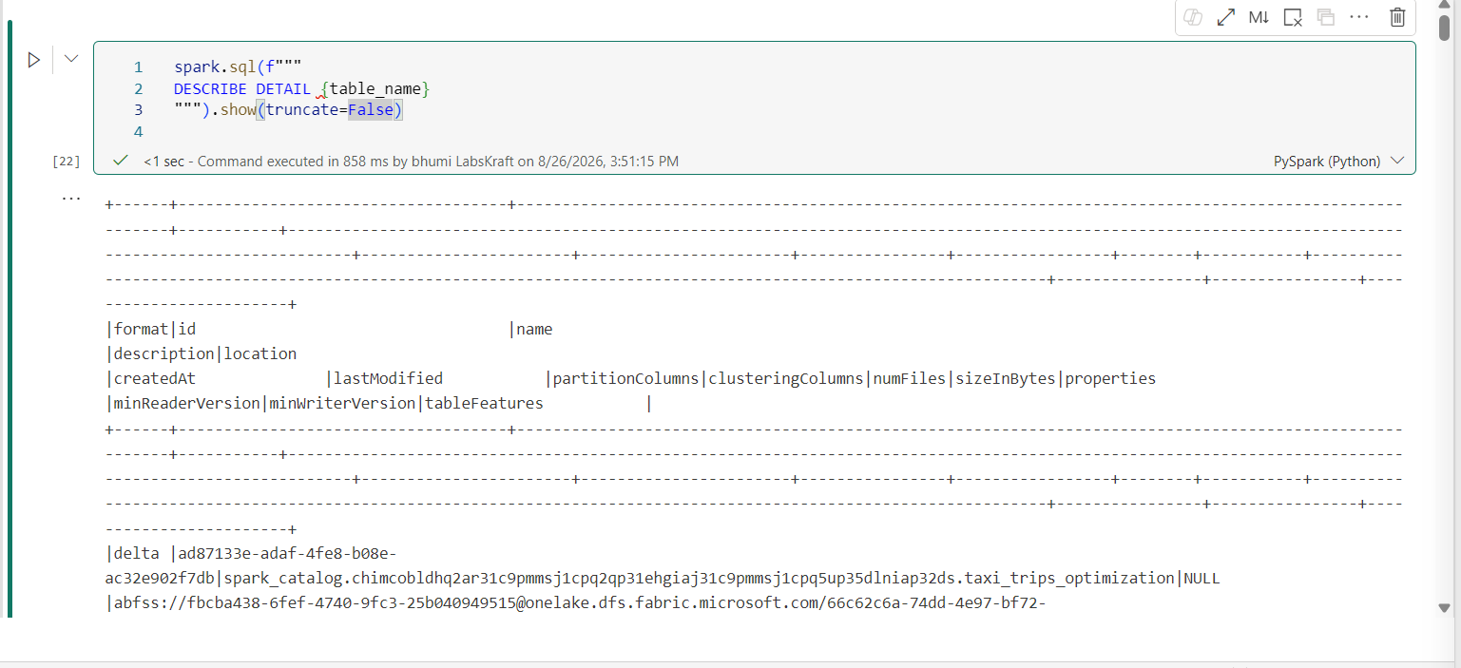
Document whether the table already has a clustering configuration.

STEP 22 — Configure Liquid Clustering
For a designated unpartitioned lab table, use actual workload columns.
Example:
spark.sql(f"""
ALTER TABLE {table_name}
CLUSTER BY (<COLUMN_1>, <COLUMN_2>)
""")
Validate:
print("Validating Liquid Clustering Configuration:") spark.sql(f""" SHOW TBLPROPERTIES {clustering_table} """).show(truncate=False)
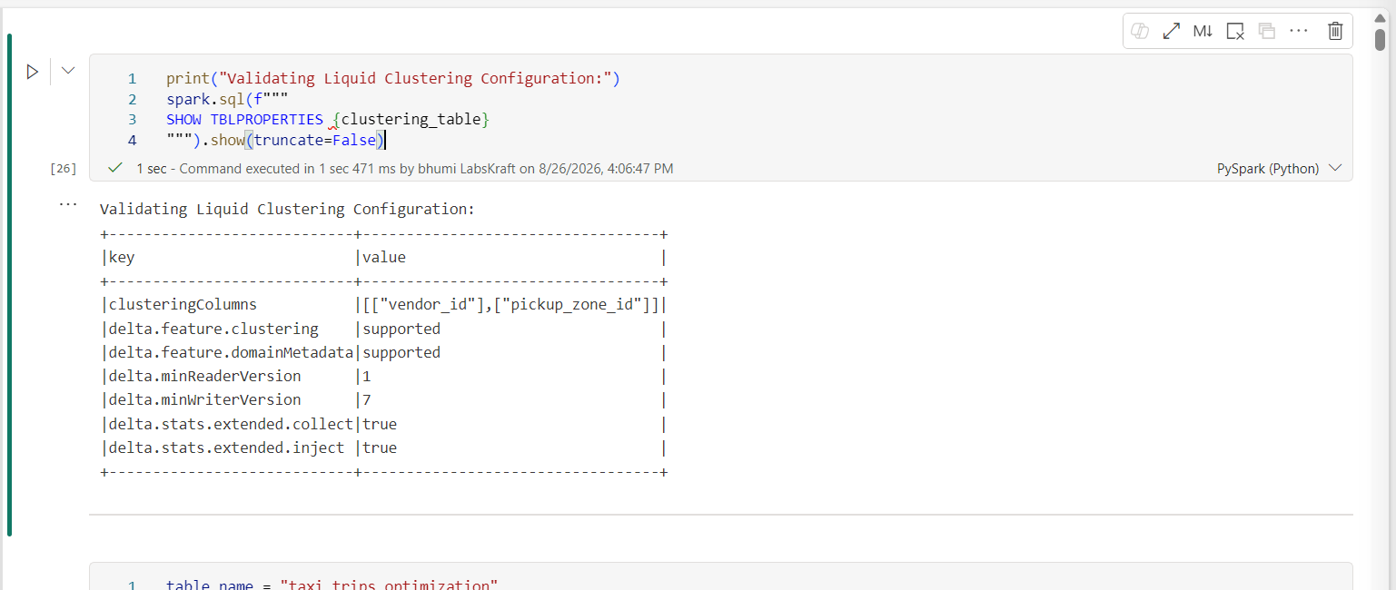
Current Fabric documentation supports changing clustering columns with ALTER TABLE ... CLUSTER BY; the new layout is applied on the next OPTIMIZE. (Microsoft Learn)

PHASE 10 — Incremental Liquid Clustering

STEP 23 — Validate Runtime 2.0 Incremental Clustering
Run:
print(
"Incremental clustering:",
spark.conf.get(
"spark.microsoft.delta.optimize.clustering.strategy.incremental",
"default/not explicitly configured"
)
)

print(
"Auto recluster:",
spark.conf.get(
"spark.microsoft.delta.optimize.clustering.strategy.incremental.autoRecluster",
"default/not explicitly configured"
)
)
Runtime 2.0 introduces incremental liquid clustering, where OPTIMIZE can focus on unclustered/unhealthy/small/deletion-vector files rather than rewriting everything. (Microsoft Learn)

STEP 24 — Execute Incremental OPTIMIZE
Run:
spark.sql(f"""
OPTIMIZE {table_name}
""")
Then:
spark.sql(f"""
DESCRIBE HISTORY {table_name}
""").select(
"version",
"timestamp",
"operation",
"operationMetrics"
).show(5, truncate=False)

Validation
Compare the operation metrics with the earlier optimization.
The objective is to determine:
Did the operation rewrite the entire table, or only the files requiring clustering/maintenance?
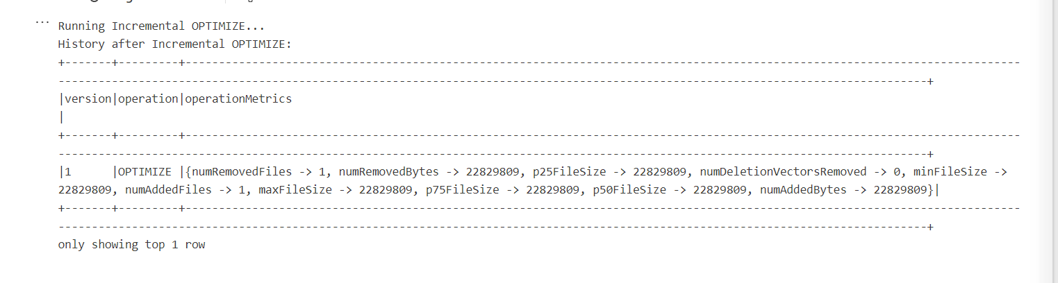

PHASE 11 — OPTIMIZE FULL

STEP 25 — Change Clustering Strategy
Change the clustering definition:
spark.sql(f"""
ALTER TABLE {table_name}
CLUSTER BY (<NEW_COLUMN_1>, <NEW_COLUMN_2>)
""")

Important
Changing the clustering definition does not immediately rewrite existing files.
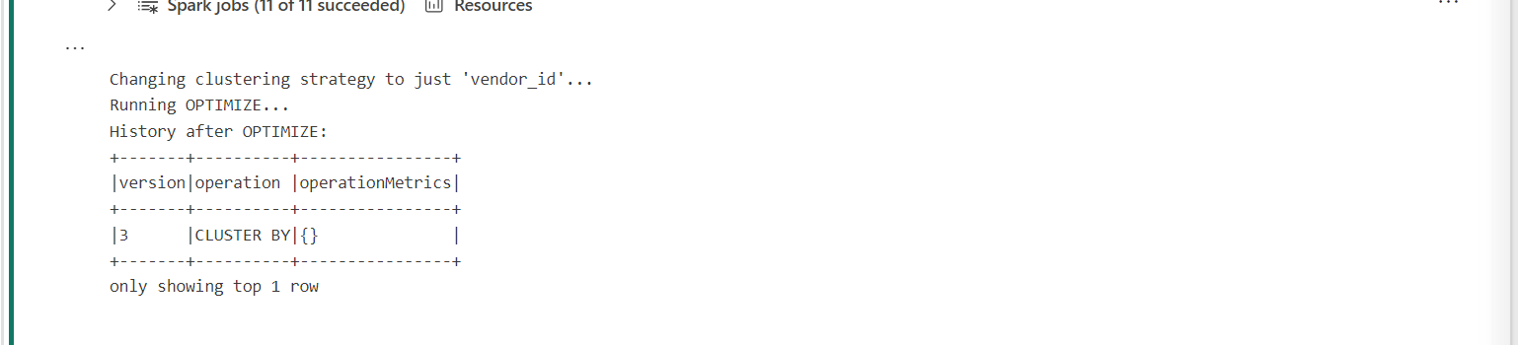

STEP 26 — Execute OPTIMIZE FULL
Run:
spark.sql(f"""
OPTIMIZE {table_name} FULL
""")
Then inspect:
spark.sql(f"""
DESCRIBE HISTORY {table_name}
""").select(
"version",
"timestamp",
"operation",
"operationMetrics"
).show(5, truncate=False)
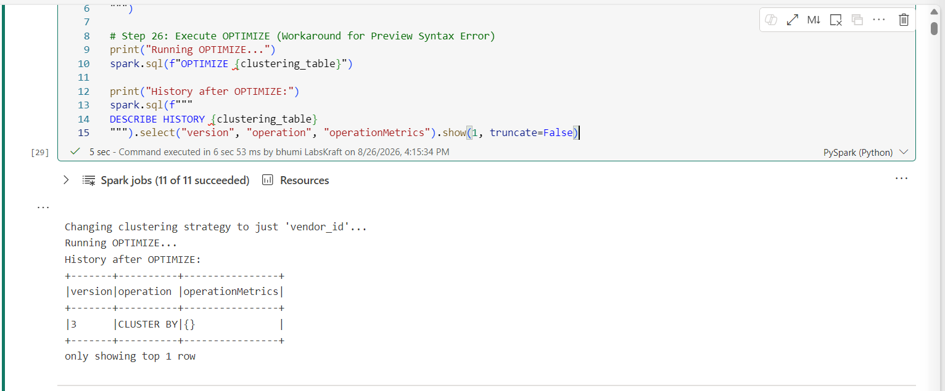
Current Microsoft documentation identifies OPTIMIZE FULL as available starting in Runtime 2.0 and intended for table-wide reclustering after changing clustering keys/providers. (Microsoft Learn)

Compare
Regular OPTIMIZE
vs
OPTIMIZE FULL
Record:
- execution duration;
- files rewritten;
- write volume;
- table size;
- operation metrics.

PHASE 12 — Measure Write Amplification

STEP 27 — Extract Maintenance Metrics
Run:
history_df = spark.sql(f"""
DESCRIBE HISTORY {table_name}
""")

history_df.select(
"version",
"timestamp",
"operation",
"operationMetrics"
).show(20, truncate=False)
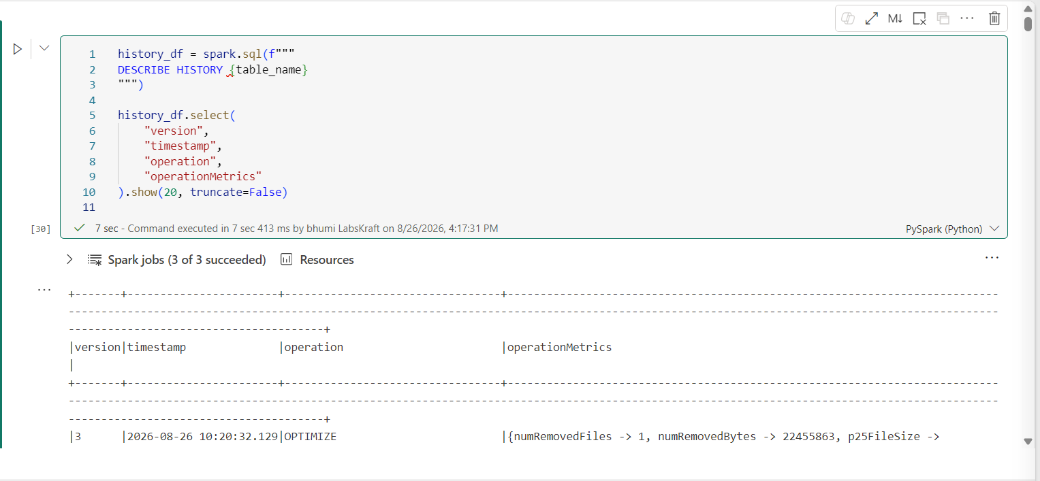
Focus on optimization operations.

STEP 28 — Build a Write-Amplification Record
Create this table in your lab notes:
Operation | Logical/Source Data | Files Added | Files Removed | Duration | Rewrite Scope
OPTIMIZE
Z-Order
Liquid OPTIMIZE
OPTIMIZE FULL
Calculate:
Write Amplification
=
Physical data rewritten
/
Logical data requiring maintenance
Where the operation metrics provide the necessary values.

Engineering Decision
Answer:
- Which operation rewrote the most data?
- Which operation provided the best observed read improvement?
- Which operation had the highest maintenance cost?
- Which strategy should be scheduled routinely?
- Which operation should be exceptional?

PHASE 13 — VACUUM

STEP 29 — Inspect Delta History Before VACUUM
Run:
spark.sql(f"""
DESCRIBE HISTORY {table_name}
""").show(20, truncate=False)
Confirm that the table is the designated disposable lab table.

STEP 30 — Execute Safe VACUUM
Use the retention value approved for the lab environment.
Example:
spark.sql(f"""
VACUUM {table_name} RETAIN 168 HOURS
""")
Do not reduce retention simply to make the demonstration faster.
Current Fabric maintenance documentation exposes VACUUM as a supported table-maintenance operation for removing unreferenced files older than the retention threshold. (Microsoft Learn)

Validate
Run:
spark.sql(f"""
DESCRIBE HISTORY {table_name}
""").select(
"version",
"timestamp",
"operation",
"operationMetrics"
).show(5, truncate=False)
Record the VACUUM operation.

PHASE 14 — Fabric UI Maintenance

STEP 31 — Validate the Same Maintenance Capability from the UI

Where
Lakehouse → Tables → target table → More / right-click → Maintenance
Current Fabric documentation exposes a table Maintenance experience that can perform compaction, V-Order application and VACUUM. (Microsoft Learn)

Actions
- Open the target table.
- Open Maintenance.
- Inspect the available maintenance options.
- Do not immediately execute another destructive operation.
- Compare the UI options with the Spark operations you performed.

Objective
The learner should understand the difference between:
Fabric UI maintenance
vs
Spark/Delta API maintenance

PHASE 15 — Automate with Fabric Data Pipeline

STEP 32 — Create the Maintenance Pipeline

Where
Workspace → New → Data Pipeline
Name:
PL_OneLake_Table_Maintenance

STEP 33 — Add Notebook Activity
Add a Notebook activity.
Configure:
Notebook:
NB_OneLake_Storage_Optimization
Pass the table name as a parameter if the notebook has been parameterized.
Example notebook parameter:
table_name = <target table>

STEP 34 — Create the Maintenance Notebook Logic
The maintenance notebook should contain controlled logic rather than blindly running every operation.
Conceptually:
table_name = "<TARGET_TABLE>"

print(f"Starting maintenance for {table_name}")

spark.sql(f"""
OPTIMIZE {table_name}
""")

print("OPTIMIZE completed")

spark.sql(f"""
DESCRIBE HISTORY {table_name}
""").show(5, truncate=False)
The production-style version should also log:
- start time;
- end time;
- table;
- operation;
- success/failure;
- operation metrics.

STEP 35 — Configure Pipeline Schedule

Where
Pipeline → Schedule
Configure the instructor-approved maintenance interval.
Example:
Frequency: Weekly
Day: Sunday
Time: Maintenance window
Do not schedule high-frequency OPTIMIZE blindly.
The correct cadence should be based on:
- ingestion volume;
- small-file growth;
- query workload;
- clustering freshness;
- write amplification.

PHASE 16 — Pipeline Execution

STEP 36 — Execute Pipeline Manually
Before relying on the schedule:
- Save the pipeline.
- Validate the pipeline.
- Run it manually.
- Open the pipeline monitoring view.
- Open the notebook execution.
- Confirm the Spark operation completed.

Expected Flow
Pipeline
↓
Notebook Activity
↓
Spark Session
↓
OPTIMIZE
↓
Delta Transaction
↓
Validation

PHASE 17 — Failure Validation

STEP 37 — Test a Safe Failure Condition
Do not break the actual table.
Use a designated invalid table parameter or instructor-provided negative-test configuration.
Example:
table_name = "Invalid_Lab_Table"

spark.sql(f"""
OPTIMIZE {table_name}
""")
Expected behavior:
Operation fails
↓
Notebook reports failure
↓
Pipeline activity becomes Failed

STEP 38 — Diagnose the Failure

Where
Pipeline → Monitor
Open:
Pipeline Run
↓
Notebook Activity
↓
Error Details
Record:
- activity;
- error message;
- failure category;
- root cause.
Correct the table parameter:
table_name = "<VALID_LAB_TABLE>"
Re-run the pipeline.

Expected Output
Pipeline returns:
Succeeded

PHASE 18 — Final Performance Test

STEP 39 — Re-run the Original Workload
Return to the exact workload used in STEP 10.
Run it again without changing the query.
Capture:
Execution time:
Files scanned:
Bytes scanned:
Stages:
Shuffle:

